VISVESVARAYA TECHNOLOGICAL UNIVERSITY

JNANA SANGAMA, BELAGAVI – 590018, KARNATAKA, INDIA

A MINI-PROJECT REPORT
ON
“RFID AND KEYPAD BASED DOOR LOCK SYSTEM USING ARDUINO”

“ELECTRONICS & COMMUNICATION ENGINEERING”

Submitted by

NAME: Puneeth. K USN: 4VP20EC024
Sanath Kumar 4VP20EC030
Vipul M S 4VP20EC044
Maneesh EC049

UNDER THE GUIDANCE: Prof. Akshay S P

___________________________________________________________________________
DEPARTMENT OF ELECTRONICS & COMMUNICATION ENGINEERING
VIVEKANANDA COLLEGE OF ENGINEERING & TECHNOLOGY
[A Unit of Vivekananda Vidyavardhaka Sangha, Puttur ®
Affiliated to Visvesvaraya Technological University, Approved by AICTE New Delhi & Govt of Karnataka]
Nehru Nagar, Puttur – 574 203, DK, Karnataka
- Phone:+91-8251-235955, 234555 Fax: 236444, Web: www.vcetputtur.ac.in, E-Mail: principal@vcetputtur.ac.in
ABSTRACT
Security is the very important role in our daily life. It must be tackled in present day. The purpose of this project is to provide a safe door lock system for houses, school, offices, industries, etc at low cost. In this project we have used RFID and keypad system. This technology can only used by the authorized person to access system. RFID is a reader to read ID cards value. In RFID it has two main components that are tag and reader. And also it has Arduino UNO, is a micro controller that controls the each and every step of system by stored program in it. After reading ID card, if it is true the Arduino allows to enter a password on keypad. If password is wrong door will not open. This project is tries to draw upon various advantages over traditional door lock system. The main view not only reduces the cost but also enhance the reliability and also easy to maintain.

CONTENTS
Chapter Title Page No.
1. INTRODUCTION 4
2. METHODOLOGY 5
2.1 Components used 5
2.2 Block diagram 8
2.3 Circuit diagram 9
2.4 How does it works? 9
3. 3.1 Applications 16
3.2 Results and Discussion 16
4. CONCLUSION 16
REFERENCES 16

CHAPTER 1
INTRODUCTION
Generally, the basic requirement of security can be done by using mechanical electric door locks. Now in this digital world, we are using the various type of security technologies. Safeguarding homes, industries, buildings, etc has become one of the important topic. The main intention of our project is to provide security. The old traditional way of method of unlocking door by lock and key is not more effective, so we have done this project. The security system applies several types of identification technologies which are magnetic strips, bar code & Radio Frequency Identification (RFID). One of the most quickly rising segments of automatic identification data by compilation manufacturing and emerging technology is a RFID in these days. The circuit of this project is very simple which contains Arduino, keypad module, buzzer, Servo Motor, LED & LCD. Arduino controls the complete processes like taking a password from the keypad module, comparing passwords, driving buzzer, rotating servo motor, and sending status to the LCD display. The keypad is used for taking the password. The buzzer is used for indication. Servo motor is used for opening the gate while rotating and LCD is used for displaying status or messages on it.

CHAPTER 2
METHODOLOGY
2.1 Components used
1.Arduino UNO:
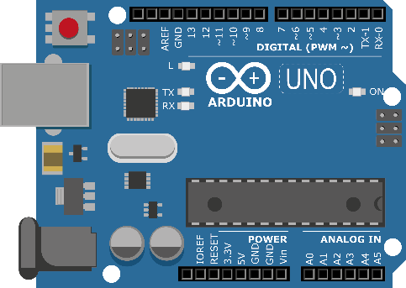

Arduino UNO is a micro controller board based on the ATmega3283. It has a 14 digital input / output pins, 6 analog pins, 16 MHz ceramic resonator, USB connection, a power jack, an ICSP header and reset button. It can be powered by the USB cable or by an external 9v battery, though it accepts voltages between 7 and 20 volts.
2.RFID reader:
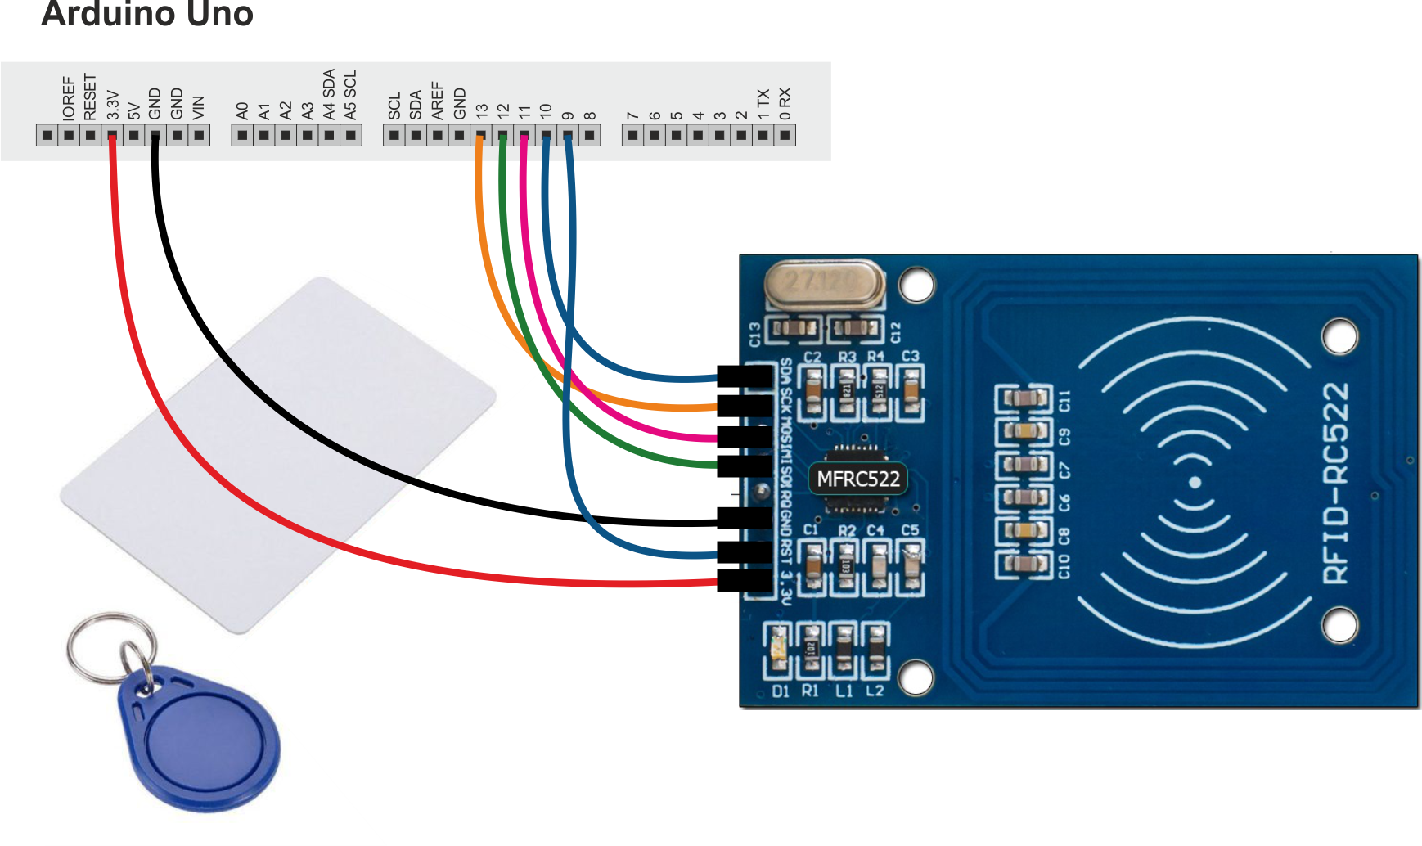

RC522 is the highly integrated RFID card reader which works on non-contact 13.56mhz communication, is designed by NXP as low power consumption, low cost and compact size read and write chip, is the best choice in the development of smart meters and portable hand-held devices.

3. 4*4 keypad:
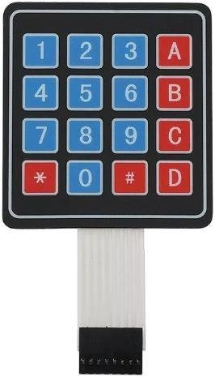

The 4*4 keypad module consists of 16 keys, these Keys are organized in a matrix of rows and columns. All these switches are connected to each other with a conductive trace. Normally there is no connection between rows and columns. When we will press a key, then a row and a column make contact.
4. SG90 Micro-servo motor:
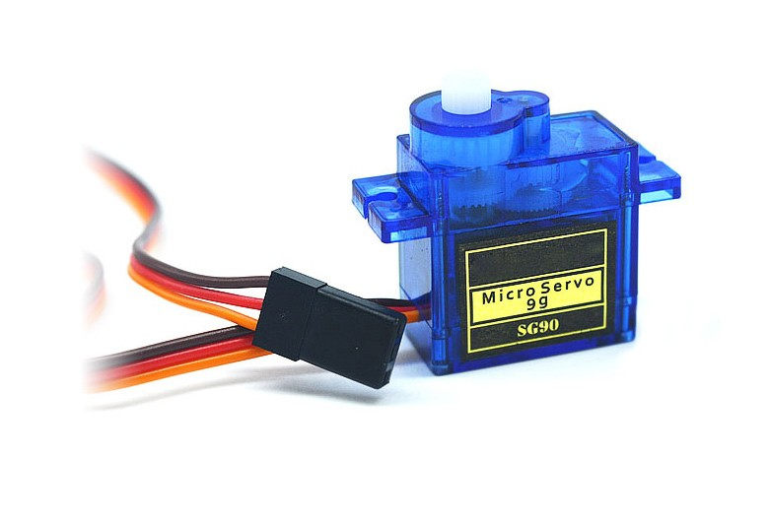

Micro Servo Motor SG90 is a tiny and lightweight server motor with high output power. Servo can rotate approximately 180 degrees (90 in each direction), and works just like the standard kinds but smaller. You can use any servo code, hardware or library to control these servos.

5.I2C LCD:
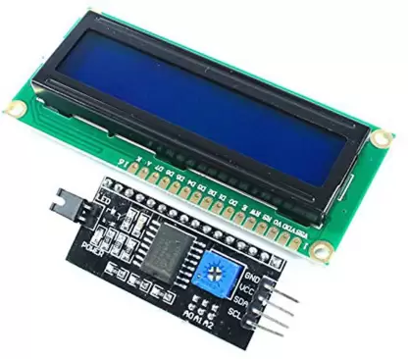

The module features a controller chip handling I2C communications and an adjustable potentiometer for changing the intensity of the LED back-light. An I2C LCD advantage is that wiring is straightforward, requiring only two data pins to control the LCD.
6. Buzzer:
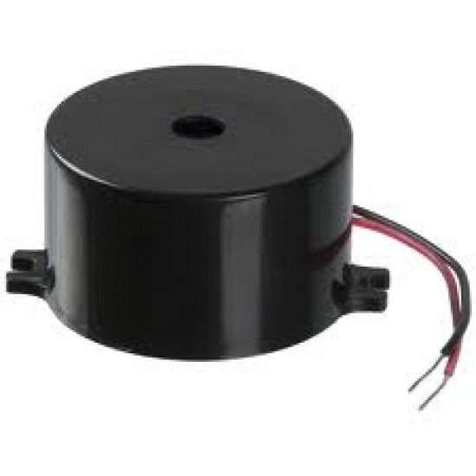

An audio signaling device like a beeper or buzzer may be electromechanical or piezoelectric or mechanical type. The main function of this is to convert the signal from audio to sound. Generally, it is powered through DC voltage and used in timers, alarm devices, printers, alarms, computers, etc. Based on the various designs, it can generate different sounds like alarm, music, bell & siren.

7. LED:
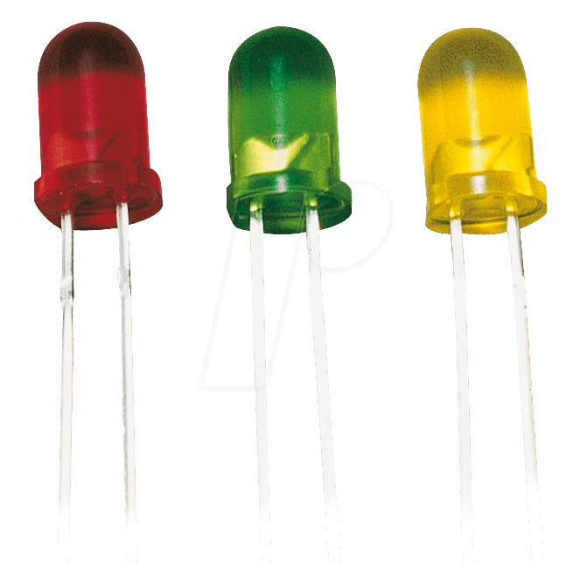

Light-emitting diode (LED) is a widely used standard source of light in electrical equipment. It has a wide range of applications ranging from your mobile phone to large advertising billboards. They mostly find applications in devices that show the time and display different types of data.
2.2 Block Diagram
RFID Reader
Keypad

Power supply
Arduino UNO
Servo motor
LCD
Power supply
Power supply
Buzzer

2.3 Circuit Diagram
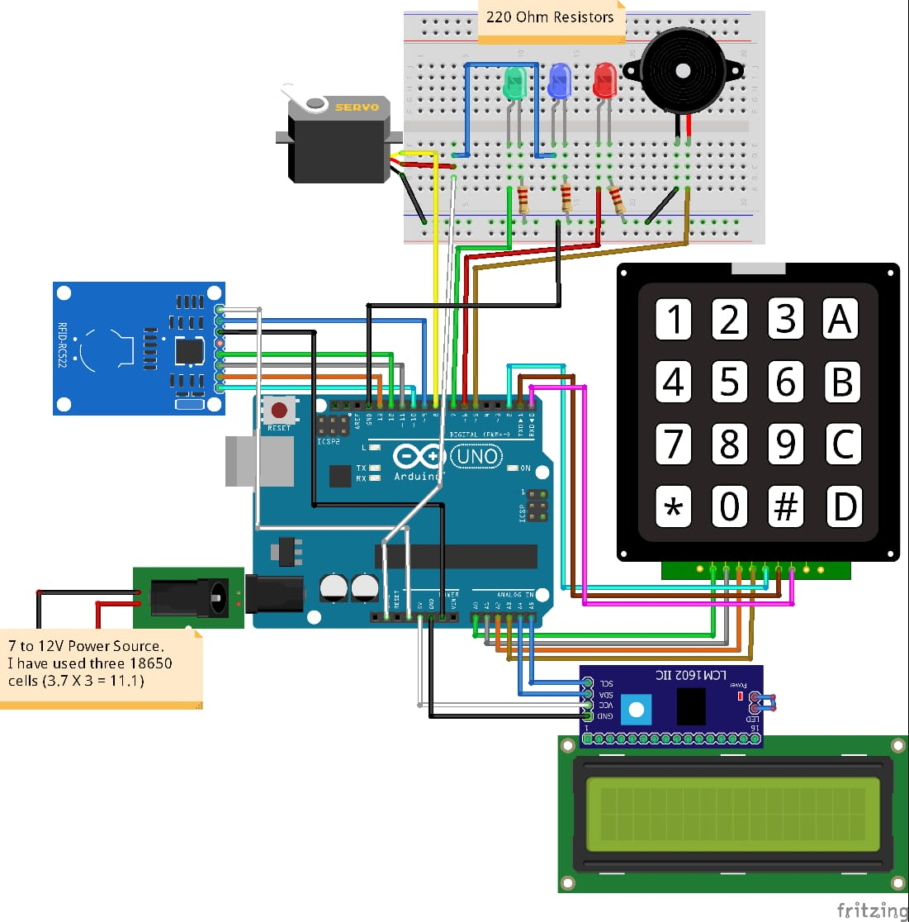

The RFID reader communicates with the Arduino through the SPI protocol and different Arduino boards have different SPI pins. To test if the RFID reader is working properly or not upload the “dump-info” from the examples in the Arduino and see if it is showing the information of the tags on the serial monitor or not. The I2C LCD communicates with the Arduino through the I2C protocol. Different Arduino boards have different I2C pins.
Next connect keypad with Arduino. The 4*4 keypad has 8 connections but we don’t require the last column of keypad. We only require number for the password. So we wont use last pin of keypad which is for fourth column. Next connect the LED’s, Servomotor and buzzer with Arduino as shown in the above diagram. In the end connect the power supply to the Arduino.
2.4 How does it works?
Initially, the door lock system will start, then we have to scan the tag on RFID(Radio Frequency Identification) reader. If the card is matched green LED will blinks then it grant access to enter the password by using the keypad and it displays status on LCD. If the tag is not matched red LED blinks and the buzzer will give warning. In display it shows ‘access denied’. While entering the password is wrong red LED will glow and buzzer starts to give warning. If the entered password is correct the servo motor is start to run and now the door will open.
Code for simulation:
// Include required libraries
#include <MFRC522.h>
#include <LiquidCrystal_I2C.h>
#include <Keypad.h>
#include <Servo.h>
#include <SPI.h>

// Create instances
LiquidCrystal_I2C lcd(0×27, 16, 2);
MFRC522 mfrc522(10, 9); // MFRC522 mfrc522(SS_PIN, RST_PIN)
Servo sg90;

// Initialize Pins for led's, servo and buzzer
// Blue LED is connected to 5V
constexpr uint8_t greenLed = 7;
constexpr uint8_t redLed = 6;
constexpr uint8_t servoPin = 8;
constexpr uint8_t buzzerPin = 5;

char initial_password[4] = {'1', '2', '3', '4'}; // Variable to store initial password
String tagUID = "F3 5A 82 0D"; // String to store UID of tag. Change it with your tag's UID
char password[4]; // Variable to store users password
boolean RFIDMode = true; // boolean to change modes
char key_pressed = 0; // Variable to store incoming keys
uint8_t i = 0; // Variable used for counter

// defining how many rows and columns our keypad have
const byte rows = 4;
const byte columns = 4;
// Keypad pin map
char hexaKeys[rows][columns] = {
{'1', '2', '3', 'A'},
{'4', '5', '6', 'B'},
{'7', '8', '9', 'C'},
{'*', '0', '#', 'D'}
};

// Initializing pins for keypad
byte row_pins[rows] = {A0, A1, A2, A3};
byte column_pins[columns] = {2, 1, 0};

// Create instance for keypad
Keypad keypad_key = Keypad(makeKeymap(hexaKeys), row_pins, column_pins, rows, columns);

void setup() {

// Arduino Pin configuration
pinMode(buzzerPin, OUTPUT);
pinMode(redLed, OUTPUT);
pinMode(greenLed, OUTPUT);

sg90.attach(servoPin); //Declare pin 8 for servo
sg90.write(0); // Set initial position at 90 degrees

lcd.init(); // LCD screen
lcd.backlight();
SPI.begin(); // Init SPI bus
mfrc522.PCD_Init(); // Init MFRC522

lcd.clear(); // Clear LCD screen
}

void loop() {

if (RFIDMode == true) {
lcd.setCursor(0, 0);
lcd.print(" Door Lock");
lcd.setCursor(0, 1);
lcd.print(" Scan Your Tag ");

// Look for new cards
if ( ! mfrc522.PICC_IsNewCardPresent()) {
return;
}

// Select one of the cards
if (! mfrc522.PICC_ReadCardSerial()) {
return;
}

//Reading from the card
String tag = "";
for (byte j = 0; j < mfrc522.uid.size; j++)
{
tag.concat(String(mfrc522.uid.uidByte[j] < 0×10? " 0": " "));
tag.concat(String(mfrc522.uid.uidByte[j], HEX));
}
tag.toUpperCase();

//Checking the card
if (tag.substring(1) == tagUID)
{
// If UID of tag is matched.
lcd.clear();
lcd.print("Tag Matched");
digitalWrite(greenLed, HIGH);
delay(3000);
digitalWrite(greenLed, LOW);

lcd.clear();
lcd.print("Enter Password:");
lcd.setCursor(0, 1);
RFIDMode = false; // Make RFID mode false
}

else
{
// If UID of tag is not matched.
lcd.clear();
lcd.setCursor(0, 0);
lcd.print("Wrong Tag Shown");
lcd.setCursor(0, 1);
lcd.print("Access Denied");
digitalWrite(buzzerPin, HIGH);
digitalWrite(redLed, HIGH);
delay(3000);
digitalWrite(buzzerPin, LOW);
digitalWrite(redLed, LOW);
lcd.clear();
}
}

// If RFID mode is false, it will look for keys from keypad
if (RFIDMode == false) {
key_pressed = keypad_key.getKey(); // Storing keys
if (key_pressed)
{
password[i++] = key_pressed; // Storing in password variable
lcd.print("*");
}
if (i == 4) // If 4 keys are completed
{
delay(200);
if (!(strncmp(password, initial_password, 4))) // If password is matched
{
lcd.clear();
lcd.print("Pass Accepted");
sg90.write(90);
delay(4000);// Door Opened
digitalWrite(greenLed, HIGH);
delay(3000);
digitalWrite(greenLed, LOW);
sg90.write(0); // Door Closed
lcd.clear();
i = 0;
RFIDMode = true; // Make RFID mode true
}
else // If password is not matched
{
lcd.clear();
lcd.print("Wrong Password");
digitalWrite(buzzerPin, HIGH);
digitalWrite(redLed, HIGH);
delay(3000);
digitalWrite(buzzerPin, LOW);
digitalWrite(redLed, LOW);
lcd.clear();
i = 0;
RFIDMode = true; // Make RFID mode true
}
}
}
}

CHAPTER 3
3.1 Applications
- RFID door lock systems for commercial office, buildings.
- Multifamily residential complexes and hotel lock systems.
- Warehouses and RFID access control technology.
3.2 Result and Discussion
It is an IoT based gadget designed for RFID and Keypad based door lock systems, developed with the help of Arduino. This gadget is managed is being managed by software programming. Let us see how this door lock system works. A 12v power adapter is used for the power supply and can also use a 9v battery instead of a power adapter. If we scan any tag which is unregistered it shows the tag is not matched and not allowed to enter the password, and the door is locked. If scanning the registered tag, it ask to enter the password and if the entered password is correct, door will open. And after few seconds door is automatically locked.
CHAPTER 4
CONCLUSION
Secure door control system is useful useful for everybody and necessary for every home, office, companies etc. The use of the Arduino UNO micro controller in this project allows design simplicity, therefore the project can be achieved in a shorter time than other technologies previously employed. The electronic lock systems are advantageous over mechanical locks. It is very low cost, very easy to use and maintain. We utilize RFID technology to provide solution for secure access of property like home, office, etc.
REFERENCES
- https://create.arduino.cc/projecthub/muhammad-aqib/rfid-and-keypad-based-door-lock-using-arduino-89e1d5
- https://www.arduino.cc/en/main/arduinoBoardUno
- https://lastminuteengineers.com/how-rfid-works-rc522-arduino-tutorial/
- https://en.wikipedia.org/wiki/Servomotor#:~:text=A%20servomotor%20(or%20servo%20motor,a%20sensor%20for%20position%20feedback.
- https://www.make-it.ca/i2c-lcd-display-on-arduino/

